Entrance most convenient to UH Parkade

Many visitors to our facility are coming from off campus and/or will be parking in the University Hospital (UH) Parkade. Entry into the Robarts building nearest the CFMM can be accessed by taking the sidewalk to the right of the gazebo just off the horseshoe drive in front of the University Hospital. (See below map “A” for detailed direction).

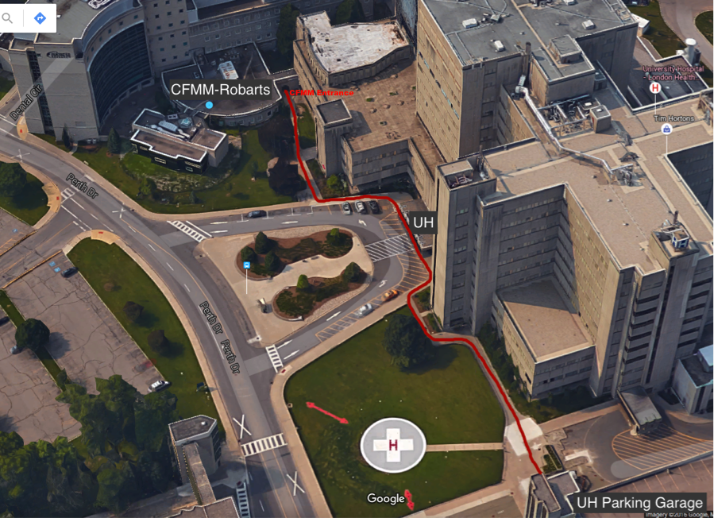
“Map A”
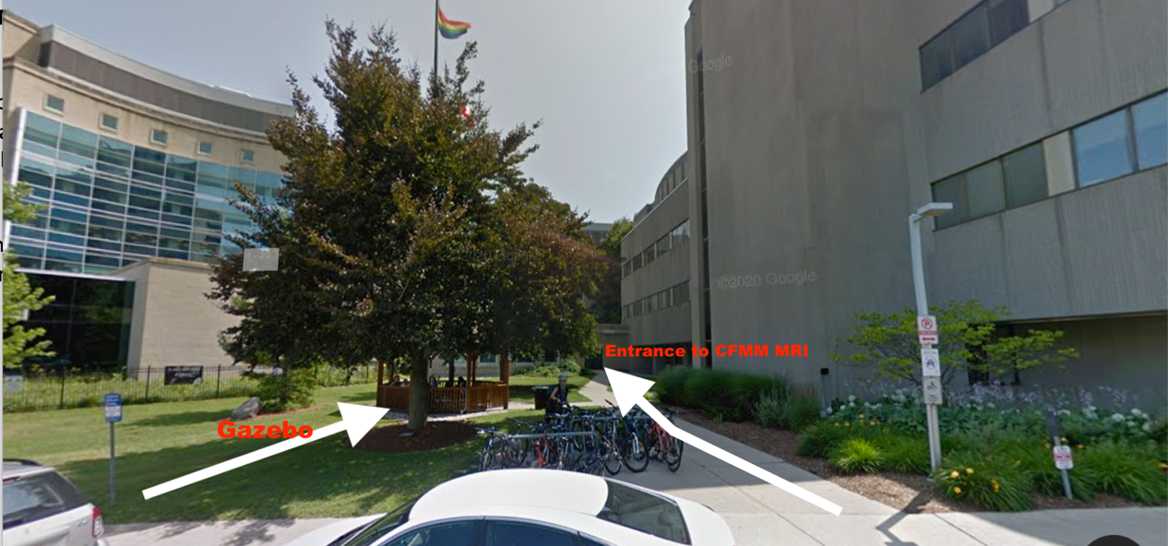

When entering through this door you can contact us from the telephone on the wall. Please call 25244 to have someone come and open this door for you.

If this entrance is not accessible for any reason please proceed to the Main Entrance of Robarts off the Dentistry Circle – see instructions and “Map B” that follows.

CFMM MRI Entrance most convenient from Western campus or alternative entrance from UH Parkade

If you are coming from the direction of the Western University campus your closest entrance into Robarts is through the main front doors off of Dentistry Circle.

These doors currently remain locked but if you have card access you can swipe your card to unlock them. If you do not have card access press the “after hours delivery button” to the left of the doors to contact the security guard who will let you in.

Once in, please sign in at the security desk and the guard will contact CFMM personnel to come and get you and bring you to your scan.

This entrance is also used when the side doors closest to the University Hospital are inaccessible due to construction.

“Map B”

